Objective:
To implement the Loop subdivision scheme through the use of Tessellation.
A brief write-up about the program:
Loop Subdivision has two phases
- Topology split
- Vertex displacements
Class File

Vertex Shader
Tessellation Control Shader

Tessellation Evaluation Shader
Fragment Shader
Geometry Shader

Class file loads the object and fetches the vertices and normal. It passes this all information to the vertex shader for further processing.
Vertex shaders are run once for each vertex given to the graphics processor.
The TCS controls how much tessellation a particular patch gets. We need to calculate control points and set the tessellation inner and outer levels. And passes this information along with patches to the Primitive generator.
The tessellation primitive generator takes the input patch and subdivides it based on values computed by the TCS.
The (TES) takes the abstract patch generated by the tessellation primitive generator stage, as well as the actual vertex data for the entire patch, and generates a particular vertex from it. We can invoke TES for each vertex or for each patch.
Geometry shader invocations take a single Primitive as input and may output zero or more primitives.
A Fragment Shader is a user-supplied program that, when executed, will process a Fragment from the rasterization process into a set of colors and a single depth value.
Loop Subdivision Algorithm (Topology split & Vertex displacements):
Generate Control points such that,
- Original vertices will be same as before.
- On each edge, two midpoints are generated
(One on 1/3 of the way the other on 2/3)
- Each midpoint is projected on the plane created by the nearest vertex and its normal.
Screenshots: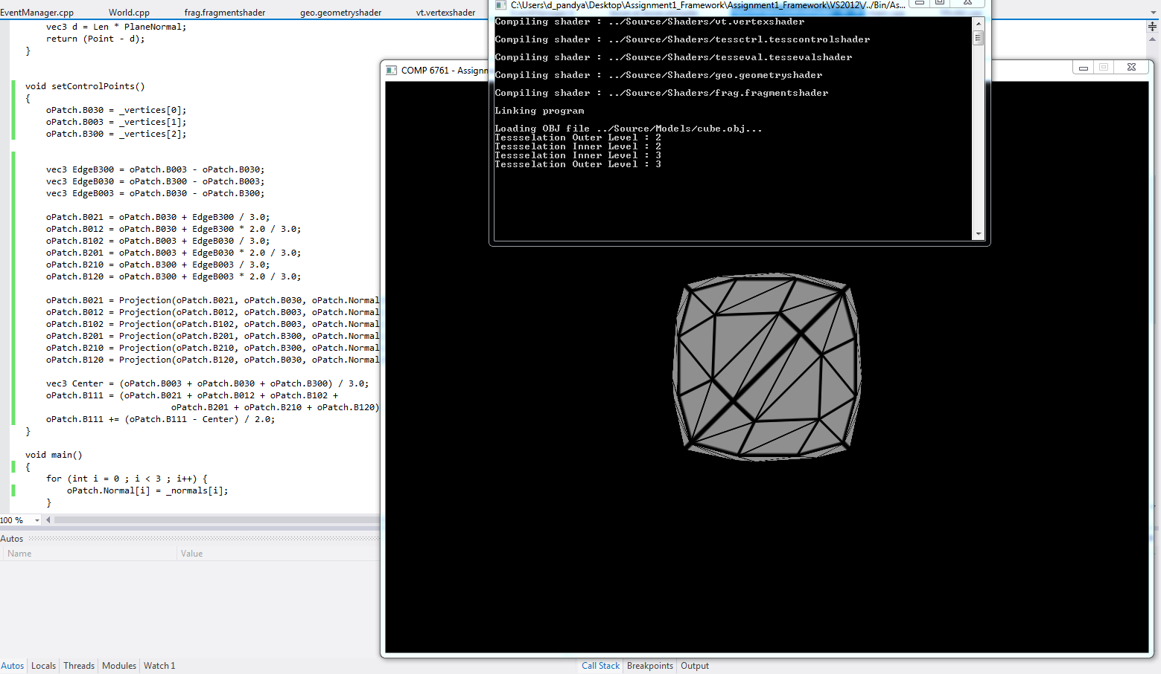

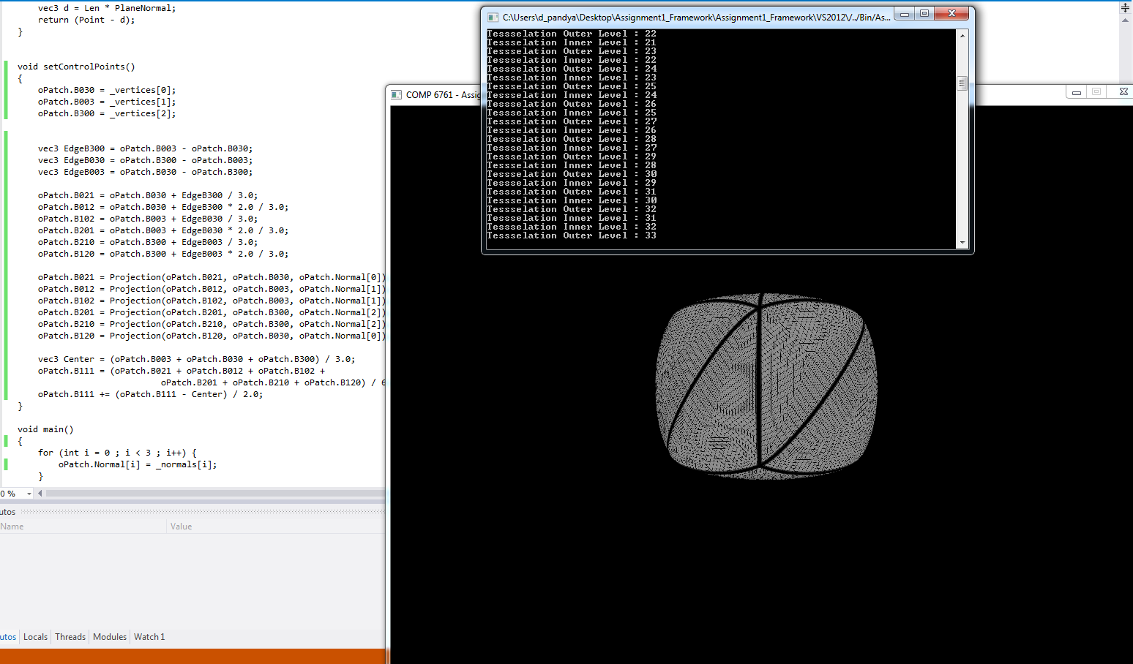

Usage Instructions:
- Open the executable file of the assignment from the bin folder.
- One cube will be displayed in grey color.
- Press NUM+4 to decrease the tessellation outer level by 1.
- Press NUM+6 to increase the tessellation outer level by 1.
- Press NUM+2 to decrease the tessellation inner level by 1.
- Press NUM+8 to increase the tessellation inner level by 1.
- Press Esc to quit.

References:

- Geometry shader file from Lab2
(https://moodle.concordia.ca/moodle/mod/resource/view.php?id=102958)
- PN-triangle Tutorial
(http://ogldev.atspace.co.uk/www/tutorial31/tutorial31.html).
- Triangle Tessellation using openGL 4.x
(http://prideout.net/blog/?p=48).

